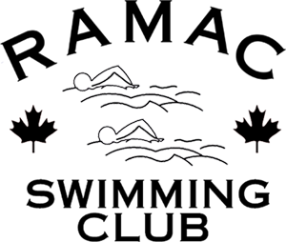
Name:

Order Form

Cotton T-Shirt

Youth Adults

Small Small

Medium Medium
Large Large

Extra Large

Price: $30

Swim Suit – TYR Polyester

Youth
8_22 12_26
10_24 14_28

Adults
- 34 38
32 36 40

Price: $30

Swim Cap - Silicone

Price: $18

Please submit cheques payable to RAMAC Inc.

